NUnit Tests
Instructions

1. Introduction
NUnit© is one of the most popular free unit testing frameworks for .NET applications. NUnit is available on http://nunit.org. For more information, refer to the “NUnit Quick Start” section for the current stable release. The Quick Start tutorial for release 2.4.8 (the stable release at the time of writing of this document) is available on http://nunit.org/index.php?p=quickStart&r=2.4.8.

2. A Quick Guide To NUnit
The NUnit tests are packaged in a DLL. A class can expose one or more test methods. The fundamental rules for constructing a NUnit test are simple:
- Any class containing test methods must be marked with the [TestFixture] attribute
- Test methods are marked with the [Test] attribute,
- Test results are verified using the methods of the Assert class (e.g. Assert.IsTrue(…), etc.),
- Expected exceptions are marked with the [ExpectedException] attribute, applied to the method where the exception is expected.
Below is a simple class demonstrating NUnit test code:

Using System;
using NUnit.Framework;

[TestFixture]
public class SampleTests
{
//
// The test below demonstrates the use of Assert methods to assert an
// expected test result.
//
[Test]
public void TestThatAlwaysPasses()
{
Assert.IsTrue(10 > 5, "10 is greater than 5 (still!)");
}

//
// The test below demonstrates the user of the [ExpectedException] attribute
// to assert an expected exception thrown within the test method.
//
[Test]
[ExpectedException(ExceptionType=typeof(ApplicationException))]
public void TestThatExpectsAnException()
{
SomeThrowingMethod();
}

private void SomeThrowingMethod()
{
throw new ApplicationException();
}
}

The test project needs to include the NUnit.Framework namespace and reference NUnit.Framework.dll.

3. Gettting NUnit
The sample NUnit tests depend on NUnit, but the TestApi package itself does not contain any NUnit binaries. Before building and running the sample NUnit tests you need to download the necessary NUnit binaries from http://nunit.org.
The provided NUnit samples assume that the following NUnit binaries are available in the “Tools\ NUnit 2.4.8” folder:

Failure.jpg
Ignored.jpg
license.txt
nunit-console-runner.dll
nunit-console.exe
nunit-gui-runner.dll
nunit.core.dll
nunit.core.extensions.dll
nunit.core.interfaces.dll
nunit.exe
nunit.fixtures.dll
nunit.framework.dll
nunit.framework.extensions.dll
nunit.mocks.dll
nunit.uikit.dll
nunit.util.dll
rowtest-license.txt
Success.jpg

It is important to note that the binaries listed above represent a subset of all NUnit binaries – it is the minimum subset, required to build and run the sample NUnit tests, provided with the TestApi library. For the complete NUnit product, refer to http://nunit.org.

4. Running NUnit Tests
To run the NUnit tests, use one of the two loaders provided with NUnit and load the test DLL in it:
- Console loader – nunit-console.exe
- GUI loader – nunit.exe
The output of a run done with the GUI loader looks as follows:
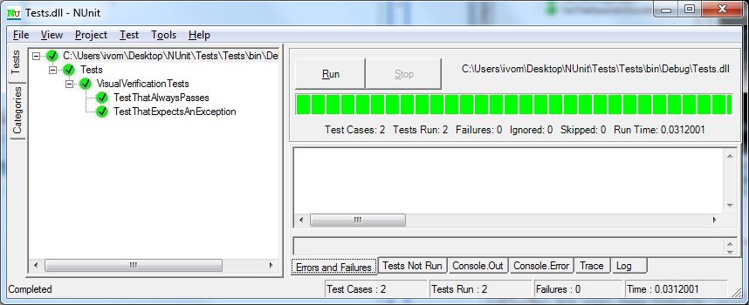
The output of a console run looks as follows:

C:\> nunit-console.exe" Tests.dll

NUnit version 2.4.8
Copyright (C) 2002-2007 Charlie Poole.
Copyright (C) 2002-2004 James W. Newkirk, Michael C. Two, Alexei A. Vorontsov.
Copyright (C) 2000-2002 Philip Craig.
All Rights Reserved.

Runtime Environment -
OS Version: Microsoft Windows NT 6.1.6956.0
CLR Version: 2.0.50727.3521 ( Net 2.0.50727.3521 )

..
Tests run: 2, Failures: 0, Not run: 0, Time: 0.031 seconds

Both methods of running tests generate TestResults.xml in the current directory containing test results in XML form.

Portions Copyright © 2002-2007 Charlie Poole or Copyright © 2002-2004 James W. Newkirk, Michael C. Two, Alexei A. Vorontsov or Copyright © 2000-2002 Philip A. Craig

